Table of Contents
1. Introduction 1
2. Objective and Requirements 1
3. Tools Used 1
4. Wireframe 1
5. Implementation 1
6. Source Code 1
7. Output Screenshots 1
8. Conclusion 1

Introduction
This document describes the design, implementation and testing of a basic interactive graphical user interface (GUI) built with Java Swing. Java Swing is a lightweight GUI toolkit in the javax.swing package that lets programmers create windows, containers and controls. Event driven programming means the program does not run in a fixed sequence; instead, it waits for events such as button clicks and responds to each one through an event handler. This assignment applies those ideas in a small application made up of a JFrame, a JPanel and a JLabel, with object-oriented concepts (inheritance and constructors) and an ImageIcon application icon.

2. Objective and Requirements
The objective is to create a basic GUI application that uses a JFrame, JLabel and JPanel, and that demonstrates inheritance and constructors. The requirements from the assignment brief were met as follows:
Requirement | How it is implemented
Class called SwingAssignment | public class SwingAssignment
JFrame variable named frame | private JFrame frame; instantiated in the constructor as new AppFrame(...)
JPanel variable named panel | private JPanel panel; instantiated with new JPanel(new GridBagLayout())
JLabel variable named label | private JLabel label; instantiated with the required welcome text
Add label to panel, panel to frame | panel.add(label, c); frame.add(panel);
Frame title and 800x800 size | AppFrame calls super(title) and setSize(800, 800)
Application closes on close button | setDefaultCloseOperation(JFrame.EXIT_ON_CLOSE)
Own icon using ImageIcon | icon.png loaded with new ImageIcon(path) and applied with setIconImage()
Inheritance | AppFrame extends JFrame (nested class)
Constructor | AppFrame(String, int, int) and SwingAssignment()
Addition: change label text | "Change Text" button calls label.setText(...)
Addition: change panel background | "Change Background" button calls panel.setBackground(...)

3. Tools Used
- Figma – to design the wireframe.
- IntelliJ IDEA / VS Code with JDK 17 or later – to write and run the Java code.
- Git and GitHub – version control and submission.

4. Wireframe
The wireframe below shows the planned layout: an 800 x 800 pixel JFrame with the title "Java Swing Assignment" and the application icon, containing one JPanel that holds the welcome JLabel and the two buttons used for the interactive additions.
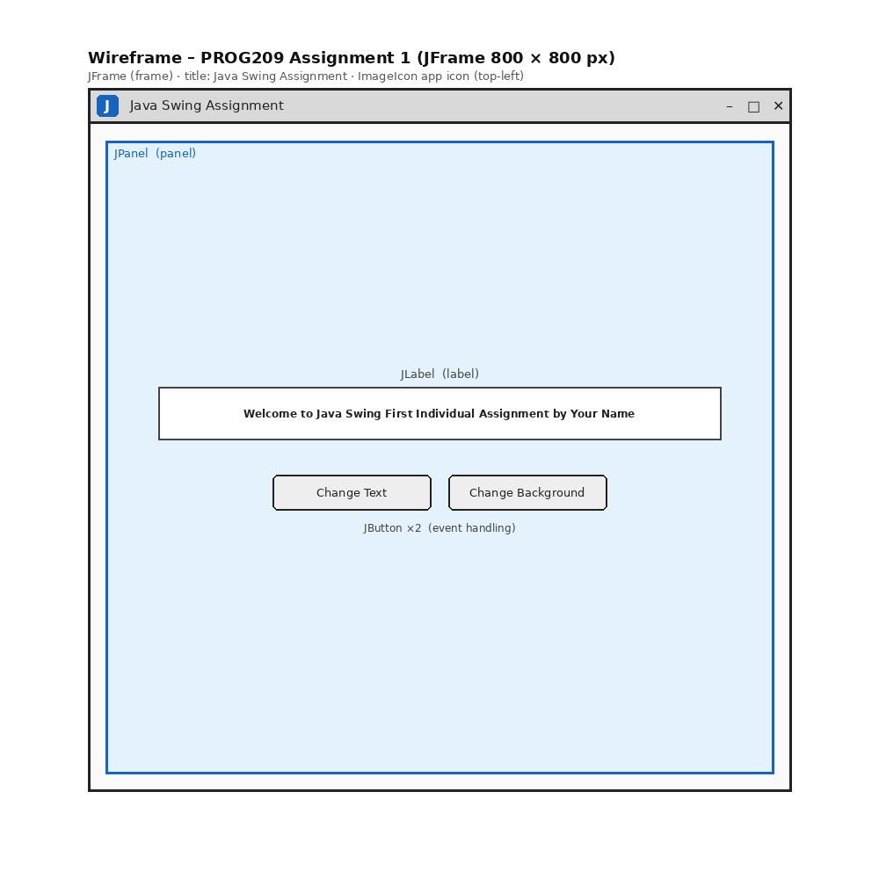
Figure 1: Wireframe of the application (replace with your Figma export if required)

5. Implementation
Inheritance. The nested class AppFrame extends JFrame, so it inherits all window behaviour (title bar, size, visibility, close handling) and adds its own configuration. The variable frame is declared as the parent type JFrame but holds an AppFrame object, which is polymorphism in practice.
Constructors. The AppFrame constructor receives a title, width and height, calls the parent constructor with super(title), then sets the size, centres the window, sets EXIT_ON_CLOSE and applies the icon. The SwingAssignment constructor creates the frame, panel, label and buttons, and assembles the GUI.
ImageIcon. The class ImageIcon loads icon.png from the project folder and its image is used as the window icon. If the file cannot be found, a fallback icon is drawn in code so that the program never fails.
Event handling. Each JButton has an ActionListener registered with a lambda expression. Clicking "Change Text" cycles through four messages; clicking "Change Background" cycles through five colours, and the label colour switches between black and white using a luminance calculation so the text always stays readable.
Thread safety. The GUI is created inside SwingUtilities.invokeLater(), which is the recommended way to start a Swing application on the Event Dispatch Thread.

6. Source Code
File: SwingAssignment.java (icon.png must be in the same folder from which the program is run).
import javax.swing.ImageIcon;
import javax.swing.JButton;
import javax.swing.JFrame;
import javax.swing.JLabel;
import javax.swing.JPanel;
import javax.swing.SwingUtilities;
import javax.swing.UIManager;
import java.awt.Color;
import java.awt.Dimension;
import java.awt.Font;
import java.awt.GridBagConstraints;
import java.awt.GridBagLayout;
import java.awt.Insets;
import java.awt.image.BufferedImage;
import java.awt.Graphics2D;
import java.awt.RenderingHints;
import java.io.File;

/**
* PROG209 - Event Driven Programming
* Assignment 1: Basic Interactive GUI (Java Swing)
*
* Demonstrates: JFrame, JPanel, JLabel, ImageIcon, inheritance, constructors,
* and event handling (change label text + change panel background).
*/
public class SwingAssignment {

// TODO: replace with your own full name
private static final String STUDENT_NAME = "Your Name";

// Required variables (names fixed by the assignment brief)
private JFrame frame;
private JPanel panel;
private JLabel label;

// Data used by the interactive "Addition" feature
private final String[] messages = {
"Welcome to Java Swing First Individual Assignment by " + STUDENT_NAME,
"Event Driven Programming is fun!",
"Hello from PROG209 - Limkokwing University, Sierra Leone",
"You just changed the text of a JLabel!"
};
private final Color[] colours = {
new Color(0xE3F2FD), new Color(0xFFF3E0), new Color(0xE8F5E9),
new Color(0xF3E5F5), new Color(0x263238)
};
private int messageIndex = 0;
private int colourIndex = 0;

/* ---------- INHERITANCE: AppFrame IS-A JFrame ---------- */
static class AppFrame extends JFrame {

// Constructor: configures everything common to the window
AppFrame(String title, int width, int height) {
super(title); // call parent constructor
setSize(width, height); // 800 x 800
setLocationRelativeTo(null); // centre on screen
setDefaultCloseOperation(JFrame.EXIT_ON_CLOSE); // app closes with the X button
setIconImage(loadAppIcon().getImage()); // own application icon
}

// Loads icon.png (ImageIcon); falls back to a drawn icon if file is missing
private static ImageIcon loadAppIcon() {
File file = new File("icon.png");
if (file.exists()) {
ImageIcon icon = new ImageIcon(file.getPath());
if (icon.getIconWidth() > 0) {
return icon;
}
}
BufferedImage img = new BufferedImage(64, 64, BufferedImage.TYPE_INT_ARGB);
Graphics2D g = img.createGraphics();
g.setRenderingHint(RenderingHints.KEY_ANTIALIASING, RenderingHints.VALUE_ANTIALIAS_ON);
g.setColor(new Color(0x1565C0));
g.fillRoundRect(0, 0, 64, 64, 18, 18);
g.setColor(Color.WHITE);
g.setFont(new Font("SansSerif", Font.BOLD, 34));
g.drawString("J", 22, 46);
g.dispose();
return new ImageIcon(img);
}
}

/* ---------- CONSTRUCTOR: builds the whole GUI ---------- */
public SwingAssignment() {
frame = new AppFrame("Java Swing Assignment", 800, 800); // JFrame instantiated

panel = new JPanel(new GridBagLayout()); // JPanel instantiated
panel.setBackground(colours[0]);

label = new JLabel(messages[0]); // JLabel instantiated
label.setFont(new Font("Tahoma", Font.BOLD, 18));
label.setHorizontalAlignment(JLabel.CENTER);

JButton textButton = new JButton("Change Text");
JButton colourButton = new JButton("Change Background");
textButton.setPreferredSize(new Dimension(170, 40));
colourButton.setPreferredSize(new Dimension(190, 40));

// Event handling (lambda expressions)
textButton.addActionListener(e -> changeText());
colourButton.addActionListener(e -> changeBackground());

// Layout: label on top, buttons underneath
GridBagConstraints c = new GridBagConstraints();
c.gridx = 0; c.gridy = 0; c.gridwidth = 2;
c.insets = new Insets(0, 10, 30, 10);
panel.add(label, c); // label -> panel

c.gridwidth = 1; c.gridy = 1;
c.insets = new Insets(0, 10, 0, 10);
c.gridx = 0; panel.add(textButton, c);
c.gridx = 1; panel.add(colourButton, c);

frame.add(panel); // panel -> frame
frame.setVisible(true);
}

// Addition 1: change the text of the JLabel
private void changeText() {
messageIndex = (messageIndex + 1) % messages.length;
label.setText(messages[messageIndex]);
}

// Addition 2: change the background of the JPanel (and keep text readable)
private void changeBackground() {
colourIndex = (colourIndex + 1) % colours.length;
Color bg = colours[colourIndex];
panel.setBackground(bg);
double luminance = (0.299 * bg.getRed() + 0.587 * bg.getGreen() + 0.114 * bg.getBlue()) / 255;
label.setForeground(luminance < 0.5 ? Color.WHITE : Color.BLACK);
}

public static void main(String[] args) {
try {
UIManager.setLookAndFeel(UIManager.getSystemLookAndFeelClassName());
} catch (Exception ignored) { }
SwingUtilities.invokeLater(SwingAssignment::new);
}
}

7. Output Screenshots
Run the program and insert clear screenshots below.
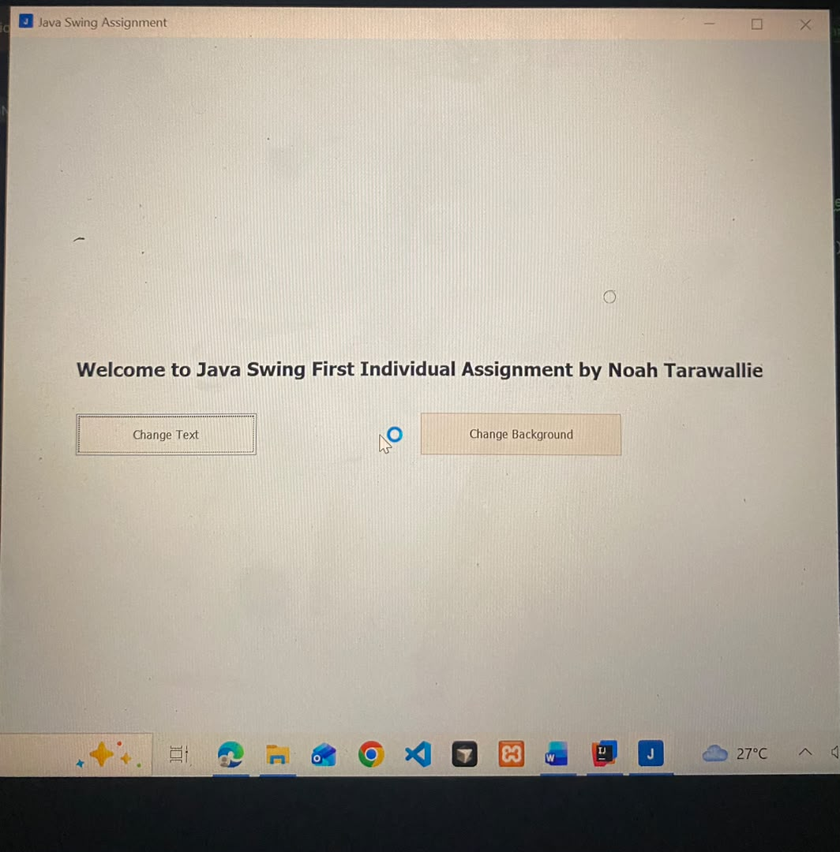
Figure 2: Application on start-up
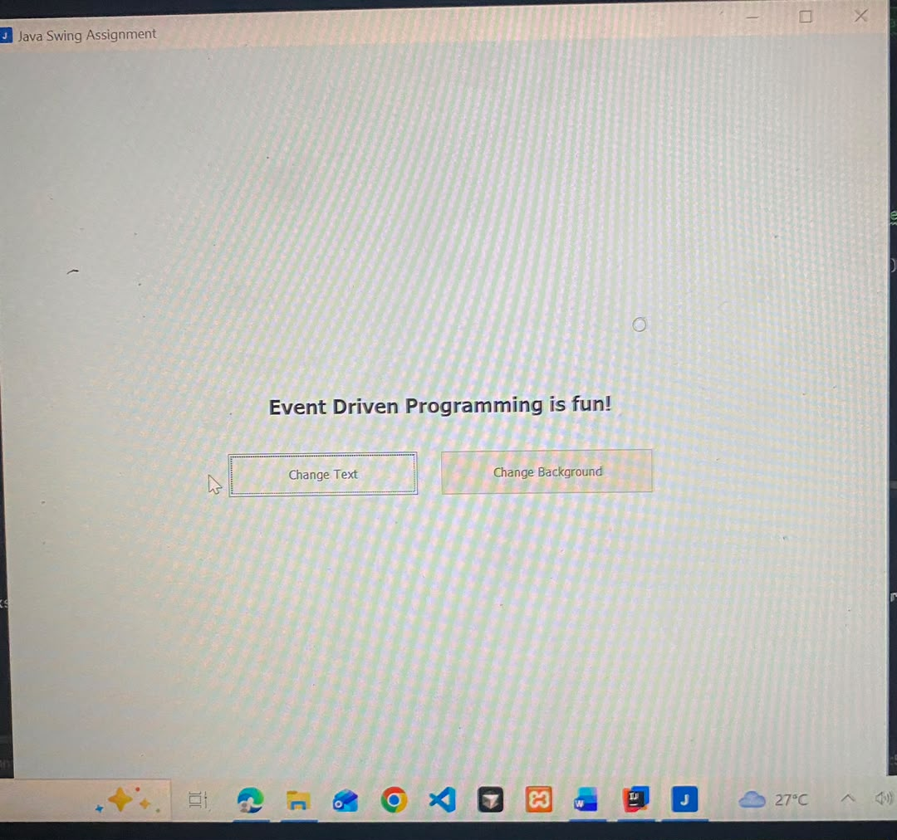

Figure 3: Label text changed
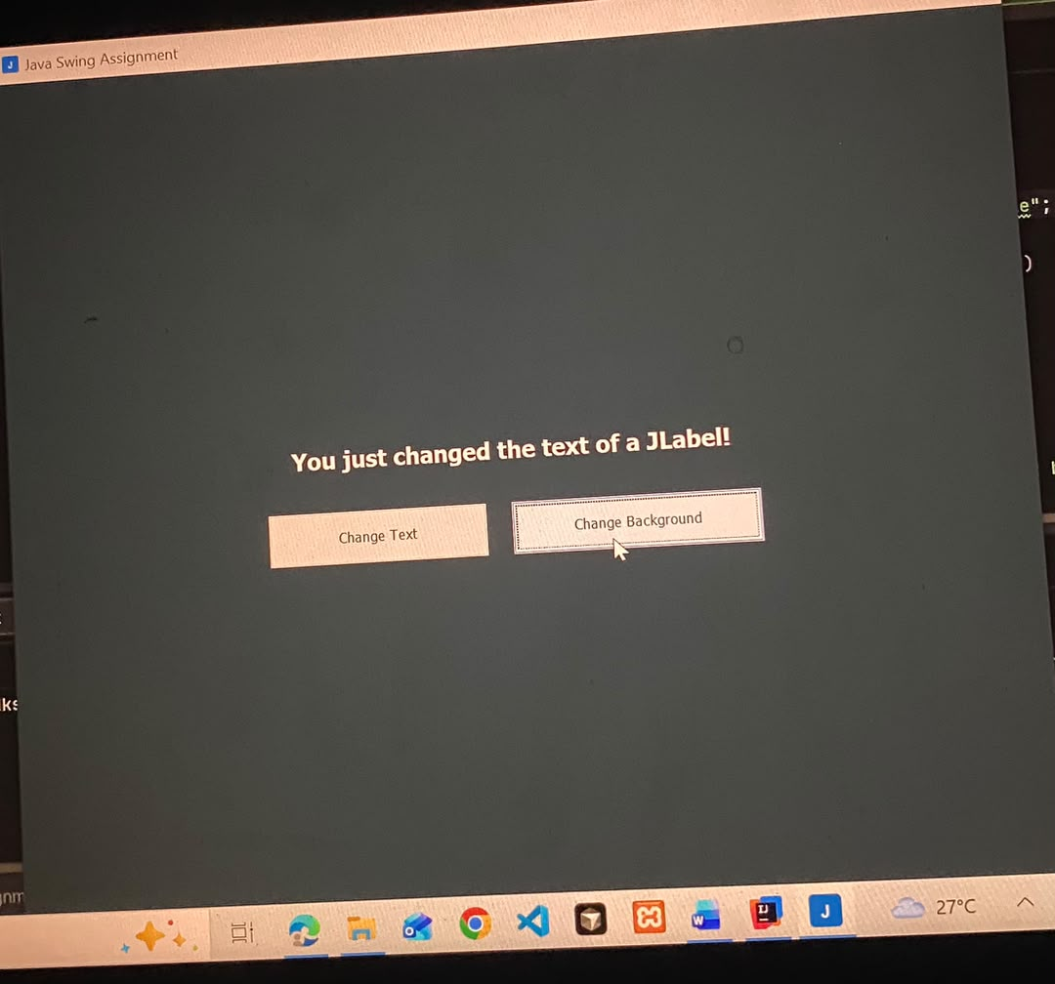
Figure 4: Panel background changed
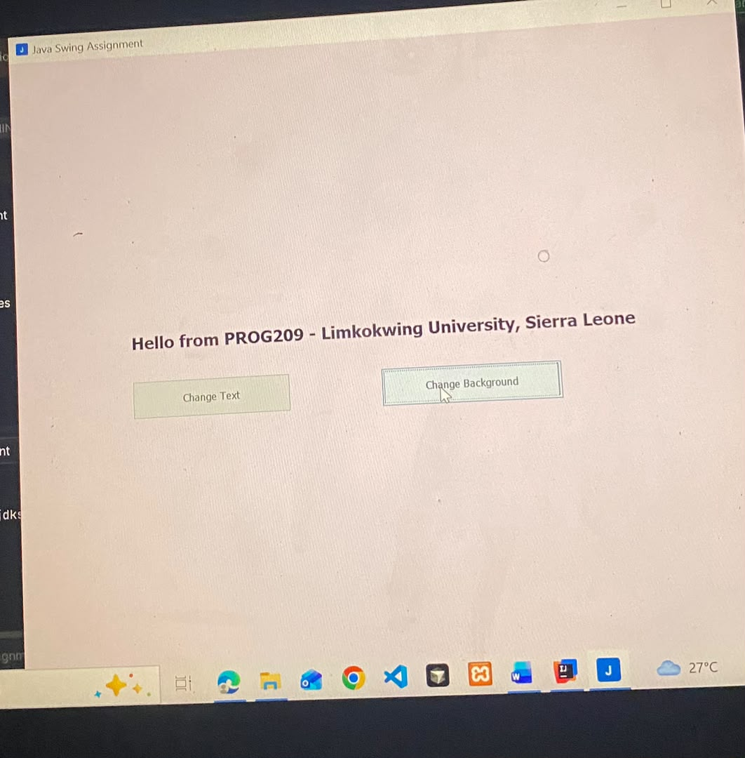

Conclusion
The application meets all requirements of the assignment brief. It shows how a JFrame, JPanel and JLabel work together, how inheritance and constructors organise GUI code, how an ImageIcon provides a custom application icon, and how event listeners make the interface interactive. Possible future improvements include a colour chooser (JColorChooser), a text field so the user can type their own label text, and a menu bar.

